LO: We are learning to make comparisons between texts and express our own opinions
Q: What are the key features of the two books?
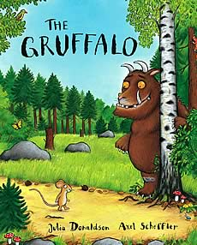 | Key Events
Characters | Settings
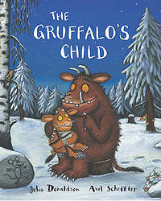 | Key Events
Characters | Settings

Q: What are the differences and similarities between The Gruffalo and The Gruffalo’s Child? Record your answers in full sentences.
Similarities
Differences

